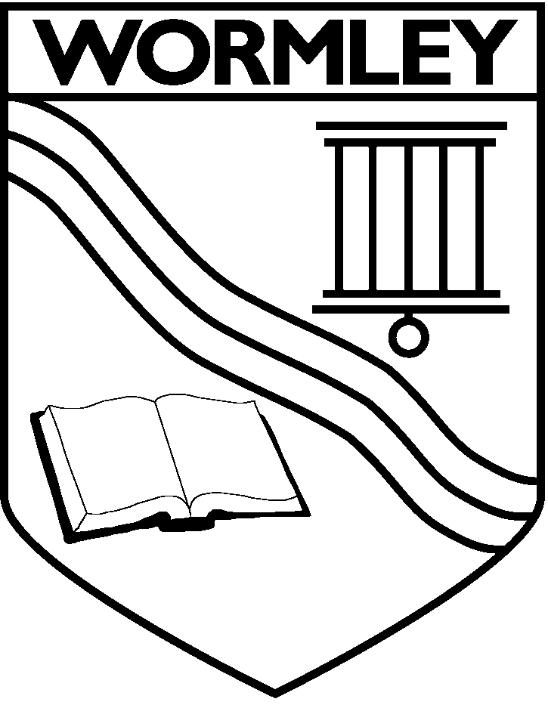
NURSERY APPLICATION FORM: WORMLEY C OF E PRIMARY SCHOOL
PLEASE USE BLOCK CAPITALS
Child details
First name:
Middle name:
Family name:
Date of birth: |  | / / |  | Gender: | M/F
NHS number: |  | / / /
Your relationship to the child: (e.g. mother/father/carer/stepmother/stepfather/social worker)
Your child’s permanent address (at time of application)
Address:
Additional information
Special Educational Needs  Does your child have a Statement of Special Educational Needs or Educational Health and Care Plan (EHCP)? |  |  |  |  |  | Yes/No
At Risk  Is your child, or a sibling of your child, subject to an inter-agency child protection plan and has been placed on the Child Protection Register? (Please provide evidence with this form) |  |  |  |  |  | Yes/No
Children in Public Care  Is your child looked after, or was previously looked after and is now adopted, or with a child arrangements or special guardianship order? |  |  |  |  |  | Yes/No
Social or medical reasons  Do you have a particular medical or social need to go to this school? (Please provide evidence with this form) |  |  |  |  |  | Yes/No
If you have a sibling at this school, please enter their name and date of birth:

Early years setting your child attends or has attended (if applicable)
Tick the provision you require:
15 hours am pm |  |  | Am or pm will be offered according to preference and availability
30 hours (am in Nursery and pm in Pre-school). |  |  | This will be offered in line with our Admissions Policy
Funded or private payment or childcare vouchers? Please specify - Parents may be eligible to get up to 30 hours free childcare. If you are eligible you must sign up online at https://www.gov.uk/help-with-childcare-costs/free-childcare-and-education-for-2-to-4-year-olds.

Please complete the details for both parents if living at the same address:

 | Parent/Carer 1 details |  |  | Parent/Carer 2 details
Title:
Forename:
Surname:
Date of birth:
National Insurance number:
National Asylum Support Service (NASS) Number
(if applicable)
Address:

Email address:

Telephone numbers:
I confirm that the details above are correct to the best of my knowledge
Signature of parent/carer:

Office Use only: |  | Date received:
 |  | Distance:
DECLARATION
The information I have given on this form is complete and accurate. I understand that my personal information will be held securely and will be used only for the schools purposes.
I agree to Wormley C of E Primary School using this information to consider my application for a nursery place. I understand that if any part of this completed application form is found false, the offer of a place will be withdrawn.
I understand that the completion of an application form does not guarantee a place in the nursery.
I understand that, if offered a place in the nursery, I will have to apply separately for a place in reception.
If I am eligible to get up to 30 hours free childcare I understand that it is up to me to apply for this funding.
If you are eligible you must sign up online at https://www.gov.uk/help-with-childcare-costs/free-childcare-and-education-for-2-to-4-year-olds.

ELIGIBILITY FOR UPTO 30 HOURS FREE CHILDCARE:
You can usually get up to 30 hours free childcare if you (and your partner) are:
- In work – or getting parental leave, sick leave or annual leave
- Each earning at least the National Minimum Wage or Living Wage for 16 hours a week
You are not eligible if:
- Your child does not usually live with you
- The child is your foster child
- Either your or your partner has a taxable income over £100,000.
You can get 30 hours free childcare at the same time as claiming Universal Credit, tax credits or childcare vouchers.
If you cannot work:
You may still be eligible if your partner is working, and you get Incapacity Benefit, Severe Disablement Allowance, Carer’s Allowance or Employment and Support Allowance.

Signature of parent/carer: ……………………………………… Date: …………………...

Thank you for completing this information. Please return to Wormley School Admissions Office by 16th March 2018.

NOTES TO PARENTS

How the information on this form will be used:

By completing this form and signing the declaration you are agreeing for Wormley C of E Primary School, if we are oversubscribed, to check whether your child’s details meet the school’s published admission rules and if he/she can be offered a nursery place.
Any personal data collected will be treated as confidential under the principles of the Data Protection Act 1998. We will not use the data for any other purpose, nor will we share your data with any third parties other than the Department for Education (for statutory reporting), Hertfordshire County Council departments who may from time to time send you advice, guidance and information relating to changes to early years provision and educational services that are relevant and/or of benefit to your child, and your local children’s centre who support the local authority by assisting families to access the services that children are entitled to.
Children who have been adopted from care or are subject to a special guardianship order or a child arrangements order.
Eligibility will be based on your declaration that your child was formally a looked after child and on the evidence of their status e.g. a copy of the relevant order. This form and a copy of the relevant order should be seen by the school and they will confirm with Hertfordshire County Council that they have seen confirmation and enable a place to be offered under this criteria.

